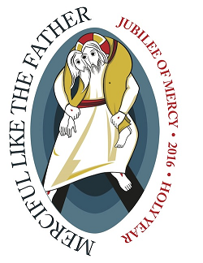NEWARK ARCHDIOCESAN “Jubilee Year of Mercy’ PILGRIMAGE to the Basilica of the National Shrine of the Immaculate Conception, Washington, DC.

One day bus trip starting from our parish at 6:30 am and returning by 10:00 pm. With a stop going down and one returning.

Saturday, October 22, 2016
Cost $30 to $50 estimated as of 7/12/16.

The Archdiocese is sponsoring a one-day pilgrimage to the Basilica. The feature of the day will be rosary devotion and concelebrating Mass in honor of Mary, Queen and Mother of Mercy.

His Holiness is asking the Church in this Jubilee Year to rediscover the richness encompassed by the spiritual and corporal works of mercy. In his announcement of this special year, Pope Francis said, “I hope the Church will be able to find in this Jubilee the joy of rediscovering and rendering fruitful God’s mercy, with which we are all called to give comfort to every man and every woman of our time.”

The Parish Pilgrimage promoter at our parish is Ray DiMuro. His contact number is 201-618-7852 (leave a voice mail), email at bk_1364@verizon.net or leave the registration form at the Rectory.
PLIGRIMAGE REGISTRATION FORM
Please enroll me as a pilgrim to the Basilica.
Name__________________________________
Address ________________________________
Town ________________________ St___ Zip ______
Phone _________________________
Email ___________________________________
Final decision by the Pilgrim will be made when the cost of the trip is provided to the Pilgrim.

